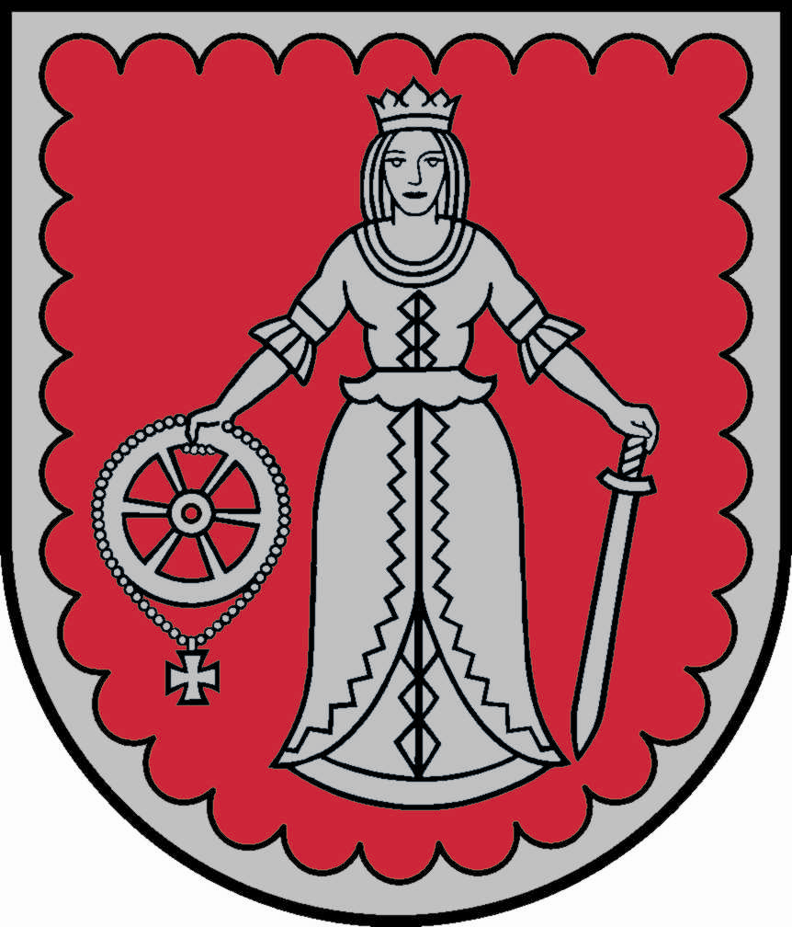 COOPERATION AGREEMENT 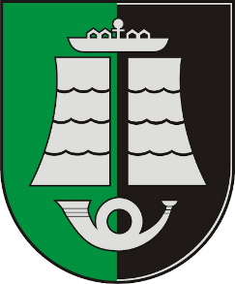

Kuldīga Municipality (Latvia) and Šilutė District Municipality (Lithuania), having taken into account traditions of friendship and cooperation between people of Lithuania and Latvia are inclined to strengthen friendly relationship and cooperation between both countries.
On the bases of common interest to develop more projects together and to share experiences in different fields, the parties sign the Cooperation Agreement on prospective of bilateral cooperation between Kuldīga Municipality and Šilutė District Municipality.
Cooperation shall be implemented in the following fields: 1) Culture; 2) Tourism; 3) Preservation of the environment. The cooperation shall be implemented also in other fields of interest of both parties and in such a way the exchange of delegations shall take place.
True friendship, mutual confidence and cooperation of inhabitants of both towns shall contribute to recognition of national traditions of Lithuania and Latvia; enable to deepen the insight into intellectual heritage, culture and history of two European countries – Lithuania and Latvia.
Cooperation of municipalities shall become a common contribution to friendship of people of Lithuania and Latvia on their way to democracy and common understanding of European countries.
The cooperation agreement is signed following Kuldīga City Council's decision on June 27, 2024 No.... and Šilutė City Council's decision on June 27, 2024 No. T1...

_____________signature*__________

Inese Astaševska
Mayor of Kuldīga Municipality
Baznīcas iela 1, Kuldīga, Kuldīgas novads, Latvija, LV-3301

____________signature*_________

Vytautas Laurinaitis
Mayor of Šilutė District Municipality
Dariaus ir Girėno gatvė 1, Šilutė
Lietuva, LT-99133

*DOCUMENT IS SIGNED WITH SECURE ELECTRONIC SIGNATURE AND CONTAINS A TIME STAMP

